Terraform Final Task.

1. Create VPC.
2. Create Internet gateway.
3. Create Custom Route Table.
4. Create Subnet.
5. Associate subnet with Route Table.
6. Create Security Group to allow port 22.80,443.
7. Create a network interface with an ip in the subnet that was created in step 4.
8. Assign an elastic IP to the network interface created in step 7.
9. Create Ubuntu server and install/enable apache2.

Final Infrastructure
The final Terraform infrastructure is:
AWS VPC
│
├── Internet Gateway
│
├── Custom Route Table
│ │
│ └── Subnet Association
│
├── Public Subnet
│ │
│ └── Network Interface
│ │
│ └── Elastic IP
│
├── Security Group
│ ├── Port 22
│ ├── Port 80
│ └── Port 443
│
└── Ubuntu EC2
│
└── Apache2

1. Objective
Objective:
Create an AWS infrastructure using Terraform with the following resources:
- VPC
- Internet Gateway
- Custom Route Table
- Subnet
- Route Table Association
- Security Group
- Network Interface
- Elastic IP
- Ubuntu EC2 server with Apache2

2. Prerequisites
Before starting, make sure the following are available:
- AWS Account
- AWS CLI configured
- Terraform installed
- VS Code
- AWS Key Pair
- AWS IAM credentials configured

3. Project Structure
I created separate Terraform files for each infrastructure component.
terraform/
│
├── provider.tf
├── vpc.tf
├── ig.tf
├── rt.tf
├── subnet.tf
├── sg.tf
├── ni.tf
├── ec2.tf
├── output.tf
│
├── .terraform/
├── .terraform.lock.hcl
└── terraform.tfstate

File Purpose
File | Purpose
provider.tf | AWS provider configuration
vpc.tf | Creates VPC
ig.tf | Creates Internet Gateway
rt.tf | Creates custom Route Table
subnet.tf | Creates Subnet
sg.tf | Creates Security Group
ni.tf | Creates Network Interface
ec2.tf | Creates Ubuntu EC2 and installs Apache
output.tf | Displays resource information

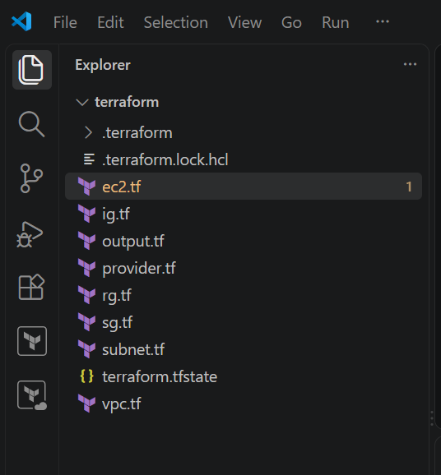

4. Terraform Provider Configuration
In provider.tf, configure the AWS provider.

# ============================================================
# PROVIDER
# ============================================================
terraform {
required_providers {
aws = {
source = "hashicorp/aws"
version = "~> 6.0"
}
}
}

provider "aws" {
region = "us-east-1"
}
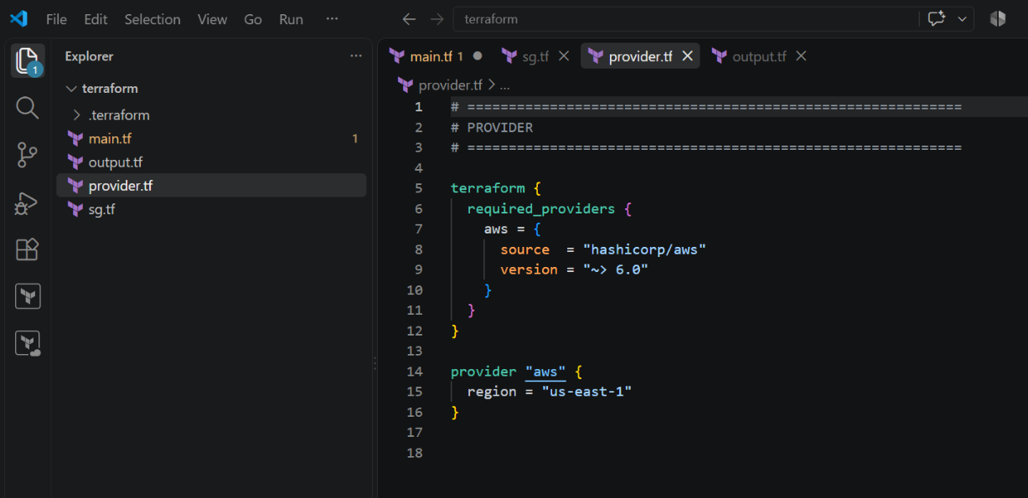

5. Create VPC
File: vpc.tf
Create a custom VPC for the infrastructure.
Example:
# ============================================================
# 1. CREATE VPC
# ============================================================

resource "aws_vpc" "main" {
cidr_block = "10.0.0.0/16"
enable_dns_support = true
enable_dns_hostnames = true

tags = {
Name = "terraform-vpc"
}
}
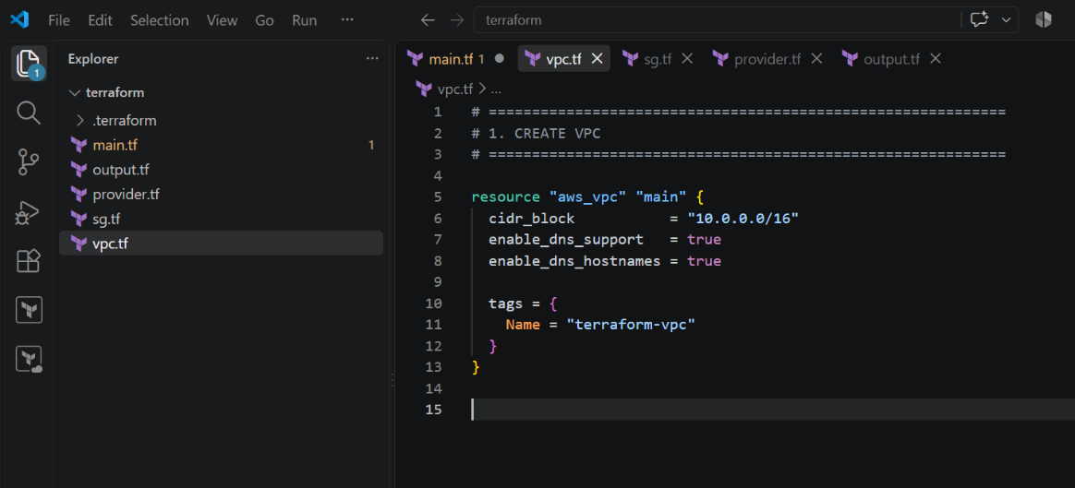

6. Create Internet Gateway
File: ig.tf
Create an Internet Gateway and attach it to the VPC.

# ============================================================
# 2. CREATE INTERNET GATEWAY
# ============================================================

resource "aws_internet_gateway" "main" {
vpc_id = aws_vpc.main.id

tags = {
Name = "terraform-internet-gateway"
}
}

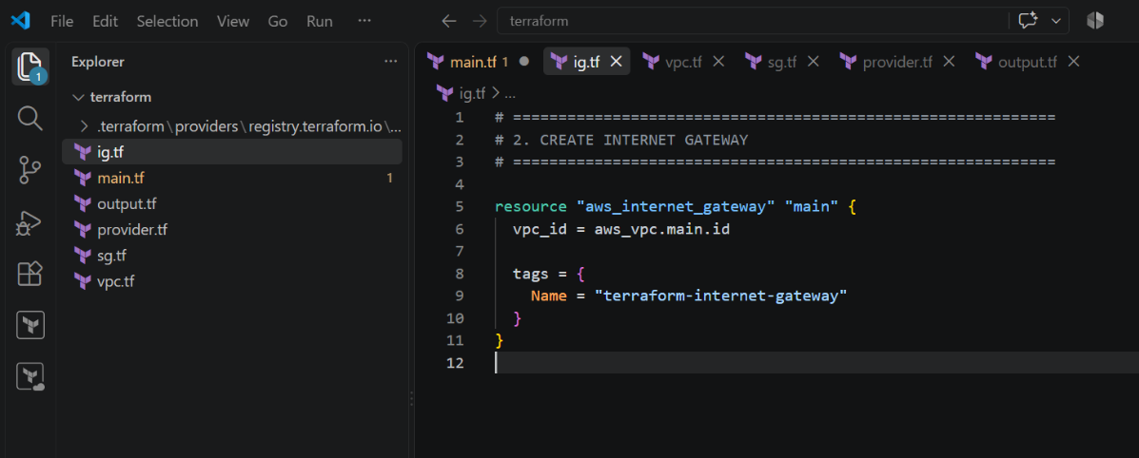

7. Create Custom Route Table
File: rt.tf
Create a custom route table for the VPC.
allows internet traffic through the Internet Gateway.
# ============================================================
# 3. CREATE CUSTOM ROUTE TABLE
# ============================================================

resource "aws_route_table" "public" {
vpc_id = aws_vpc.main.id

route {
cidr_block = "0.0.0.0/0"
gateway_id = aws_internet_gateway.main.id
}

tags = {
Name = "terraform-public-route-table"
}
}

8. Create Subnet
File: subnet.tf
Create a subnet inside the VPC.
Example:
# ============================================================
# 4. CREATE SUBNET
# ============================================================

resource "aws_subnet" "public" {
vpc_id = aws_vpc.main.id
cidr_block = "10.0.1.0/24"
availability_zone = "us-east-1a"
map_public_ip_on_launch = false

tags = {
Name = "terraform-public-subnet"
}
}

9. Associate Subnet with Route Table
# ============================================================
# 5. ASSOCIATE SUBNET WITH ROUTE TABLE
# ============================================================

resource "aws_route_table_association" "public" {
subnet_id = aws_subnet.public.id
route_table_id = aws_route_table.public.id
}

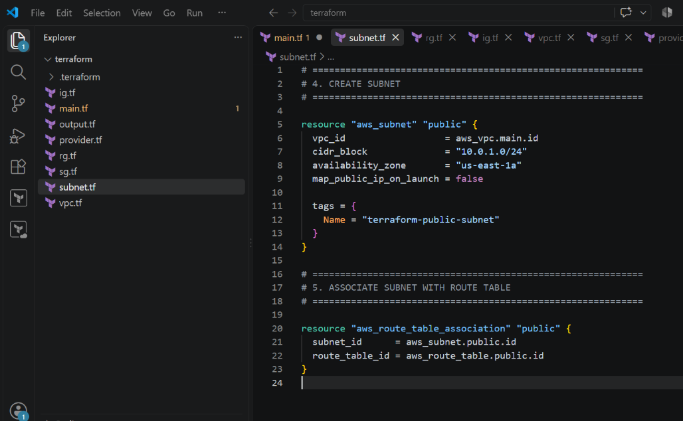
10. Create Security Group
File: sg.tf
# ============================================================
# 6. CREATE SECURITY GROUP
# ALLOW PORTS 22, 80, 443
# ============================================================

resource "aws_security_group" "web" {
name = "terraform-web-security-group"
description = "Allow SSH HTTP and HTTPS"
vpc_id = aws_vpc.main.id

# SSH - Port 22
ingress {
description = "SSH"
from_port = 22
to_port = 22
protocol = "tcp"
cidr_blocks = ["0.0.0.0/0"]
}

# HTTP - Port 80
ingress {
description = "HTTP"
from_port = 80
to_port = 80
protocol = "tcp"
cidr_blocks = ["0.0.0.0/0"]
}

# HTTPS - Port 443
ingress {
description = "HTTPS"
from_port = 443
to_port = 443
protocol = "tcp"
cidr_blocks = ["0.0.0.0/0"]
}

# Allow all outbound traffic
egress {
description = "All outbound traffic"
from_port = 0
to_port = 0
protocol = "-1"
cidr_blocks = ["0.0.0.0/0"]
}

tags = {
Name = "terraform-web-security-group"
}
}

# ============================================================
# 7. CREATE NETWORK INTERFACE
# PRIVATE IP = 10.0.1.10
# ============================================================

resource "aws_network_interface" "web" {
subnet_id = aws_subnet.public.id
private_ips = ["10.0.1.10"]
security_groups = [aws_security_group.web.id]

tags = {
Name = "terraform-web-network-interface"
}
}

# ============================================================
# 8. CREATE ELASTIC IP
# ASSIGN IT TO NETWORK INTERFACE
# ============================================================

resource "aws_eip" "web" {
domain = "vpc"
network_interface = aws_network_interface.web.id
associate_with_private_ip = "10.0.1.10"

tags = {
Name = "terraform-web-elastic-ip"
}

depends_on = [
aws_internet_gateway.main
]
}
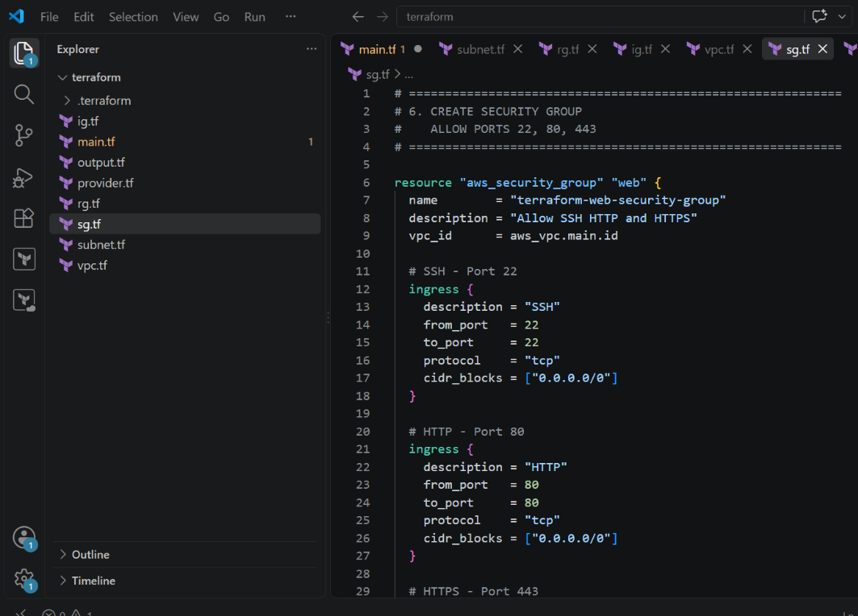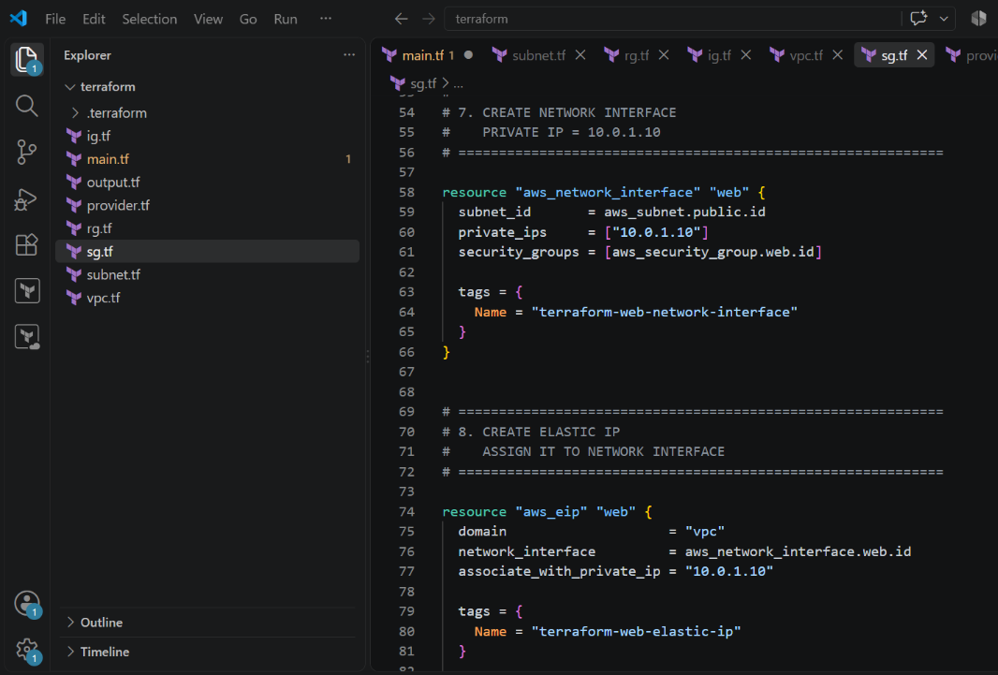
13. Create Ubuntu Server and Install Apache2
File: ec2.tf
Create the Ubuntu EC2 instance.
# ============================================================
# 9. CREATE UBUNTU SERVER
# INSTALL AND ENABLE APACHE2
# ============================================================

resource "aws_instance" "ubuntu" {
ami = "ami-0b6d9d3d33ba97d99"
instance_type = "t3.micro"
key_name = "ubuntu"

network_interface {
network_interface_id = aws_network_interface.web.id
device_index = 0
}

user_data = "#!/bin/bash\napt-get update -y\napt-get install -y apache2\nsystemctl enable apache2\nsystemctl start apache2\necho '<h1>Apache2 Server Created Using Terraform by Sarfaraz</h1>' > /var/www/html/index.html"

tags = {
Name = "terraform-ubuntu-apache-server"
}

depends_on = [
aws_eip.web
]
}

14. Terraform Deployment
Run the following commands from the Terraform directory.
Initialize
$ terraform init
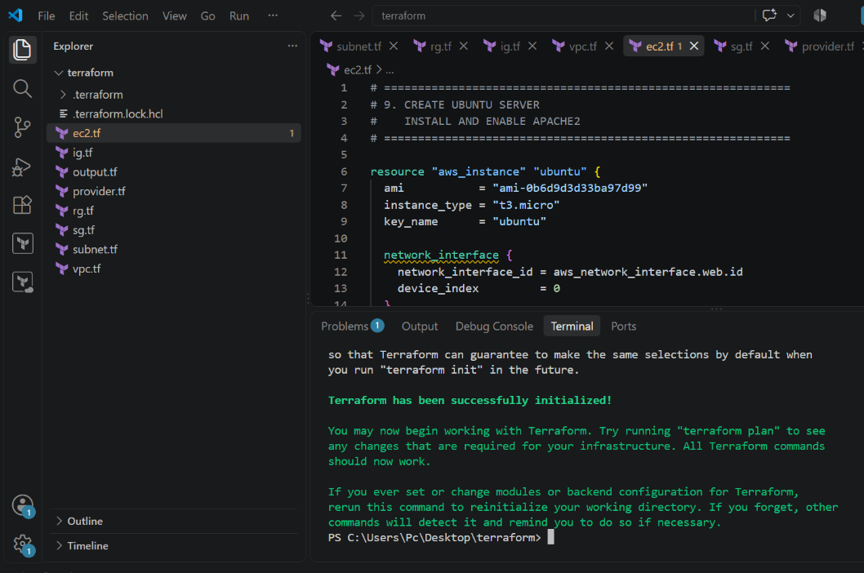
Validate
$ terraform validate
Expected:
Success! The configuration is valid.
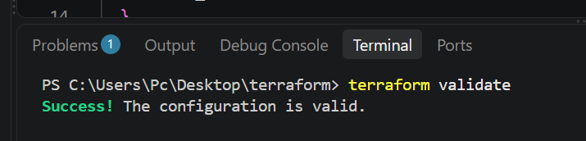
Format
$ terraform fmt
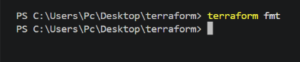
Plan
$ terraform plan
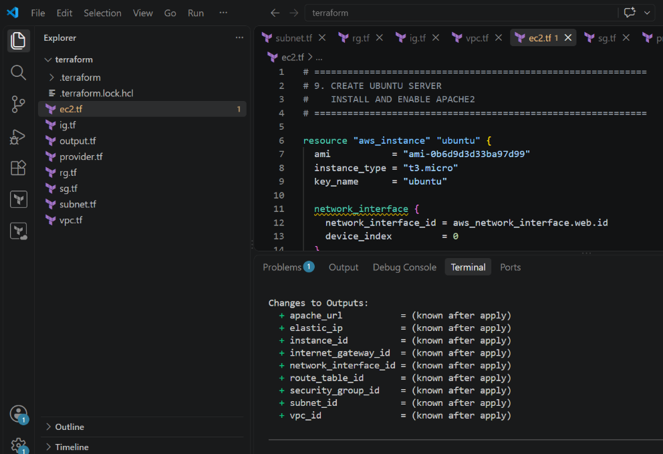
Apply
$ terraform apply
Enter:
yes
Apply complete!
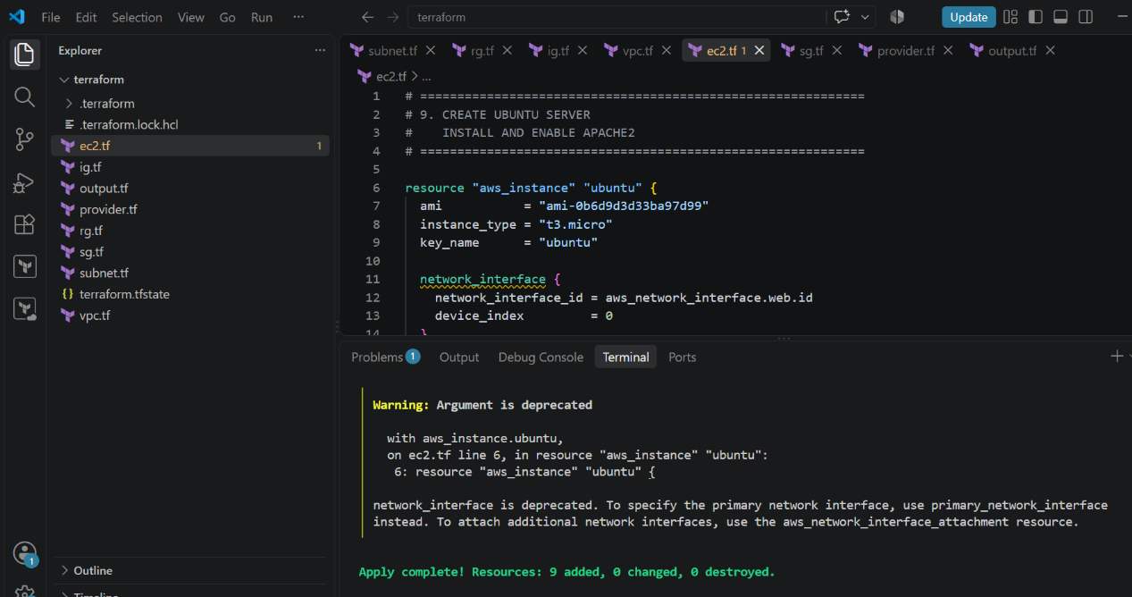

15. Verify Terraform Outputs
Run:
terraform output
Your current output already shows values such as:
apache_url
elastic_ip
instance_id
internet_gateway_id
network_interface_id
route_table_id
security_group_id
subnet_id
vpc_id
terraform output
and all the resource IDs.
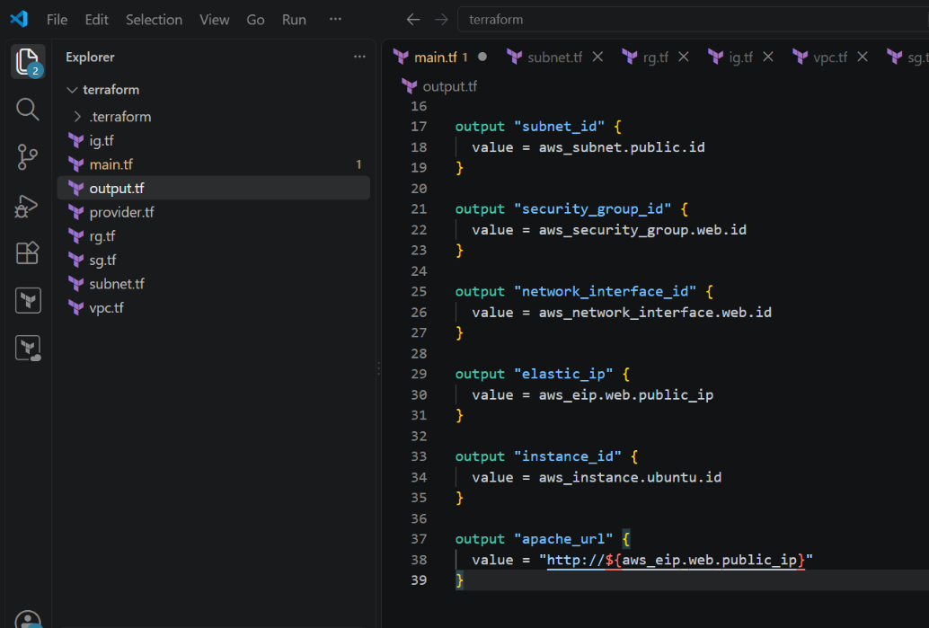
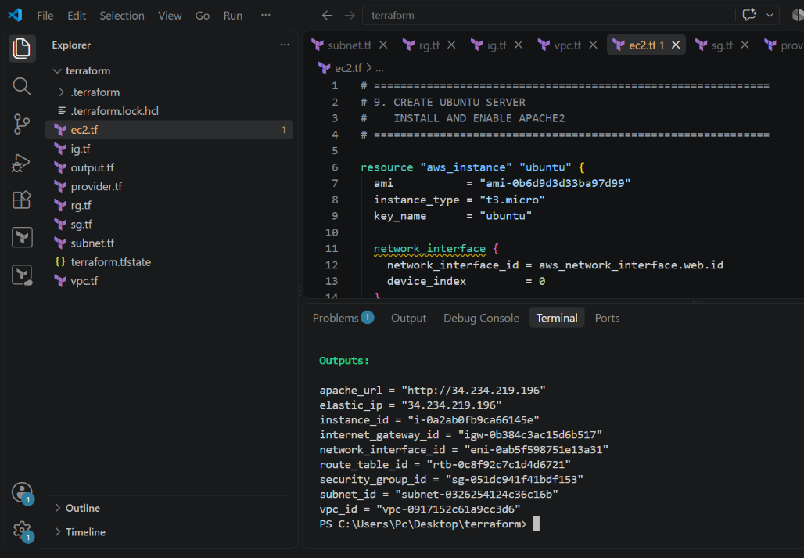

16. Verify Apache Web Server
Copy the Apache URL from Terraform output.
Example:
http://34.234.219.196
Open it in your browser.
You should see the:
Apache2 Ubuntu Default Page
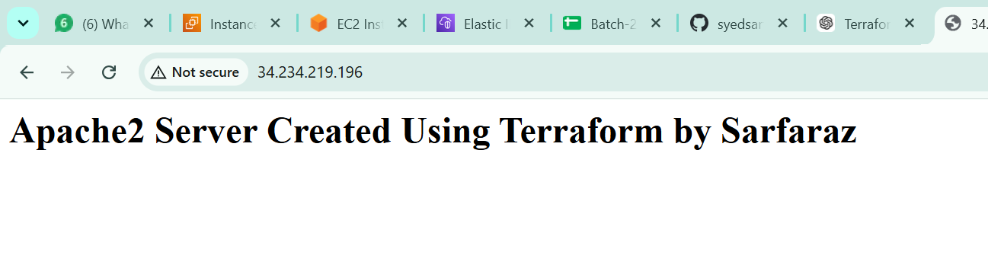

Infrastructure Images
- VPC
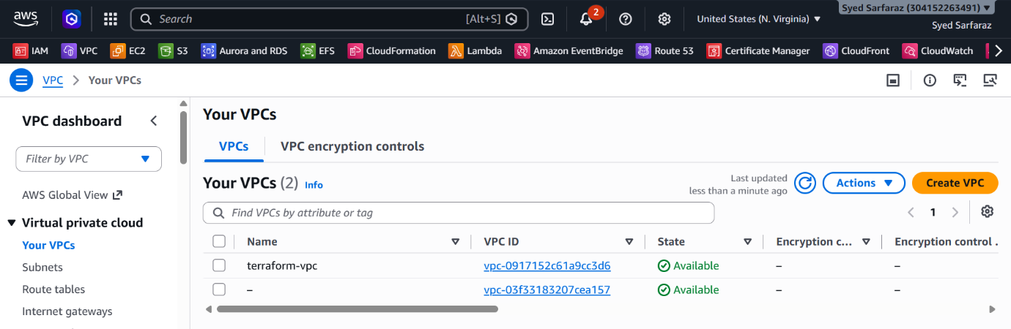

- SUBNET
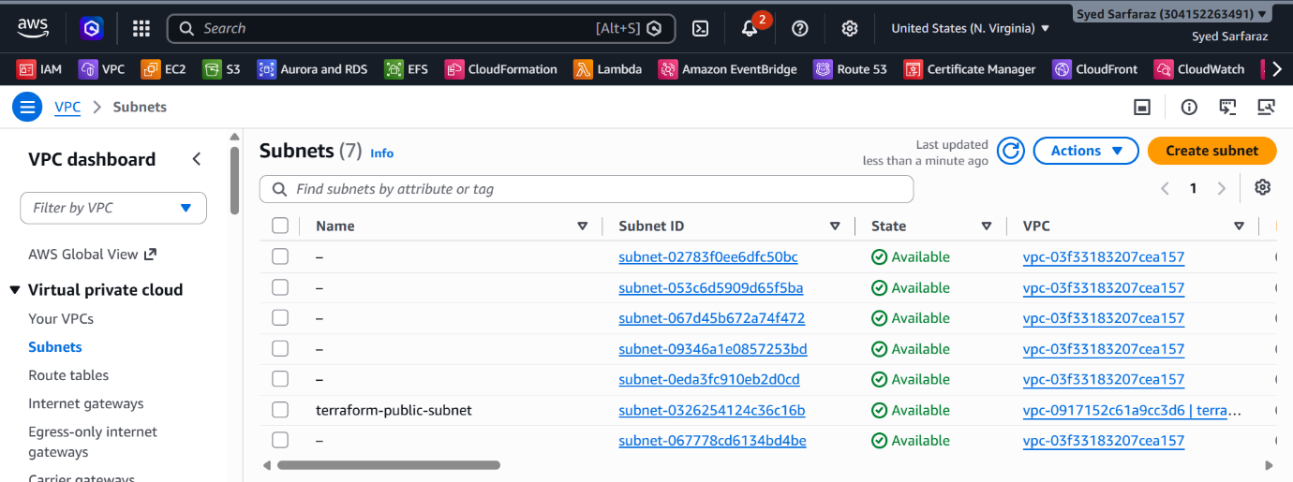

- INTERNET GATEWAY
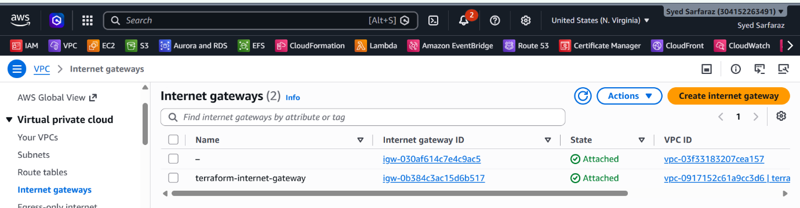

- ROUTE TABLE
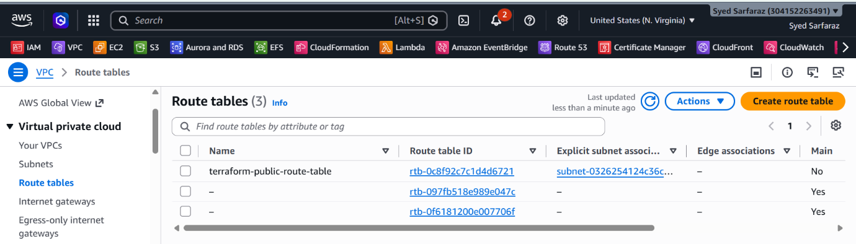

- SECURITY GROUP
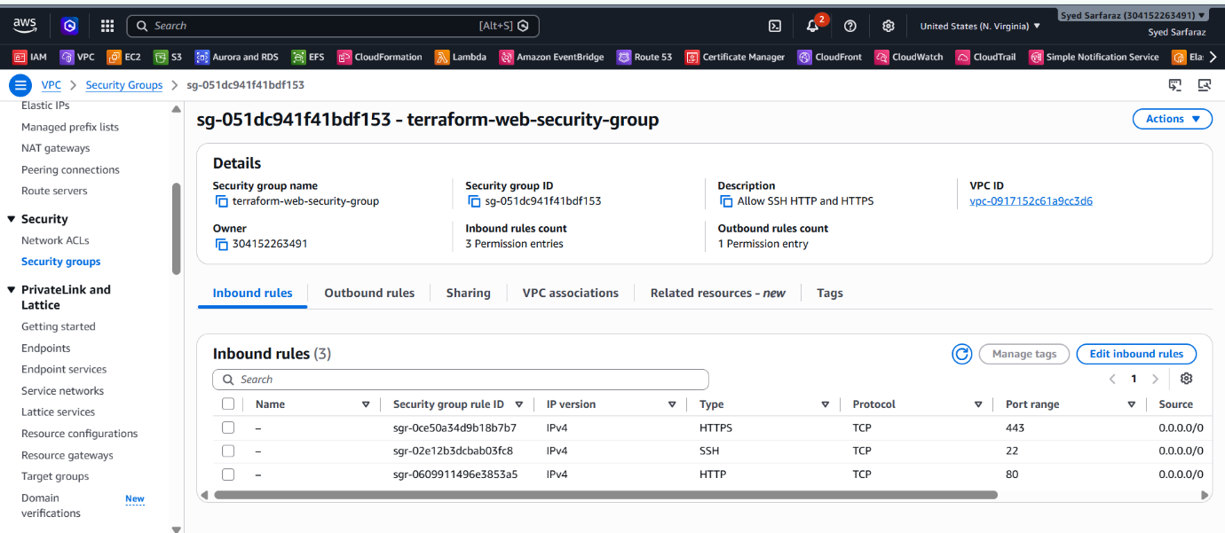

- ELASTIC IP
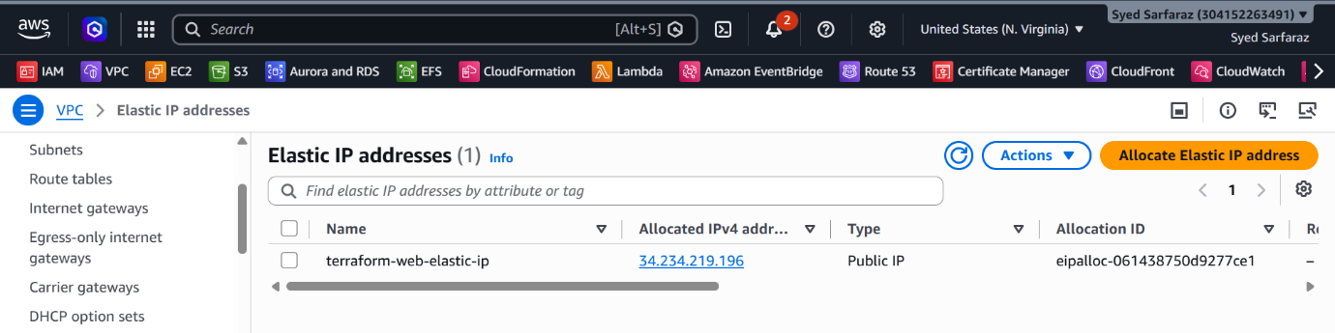

- SERVER
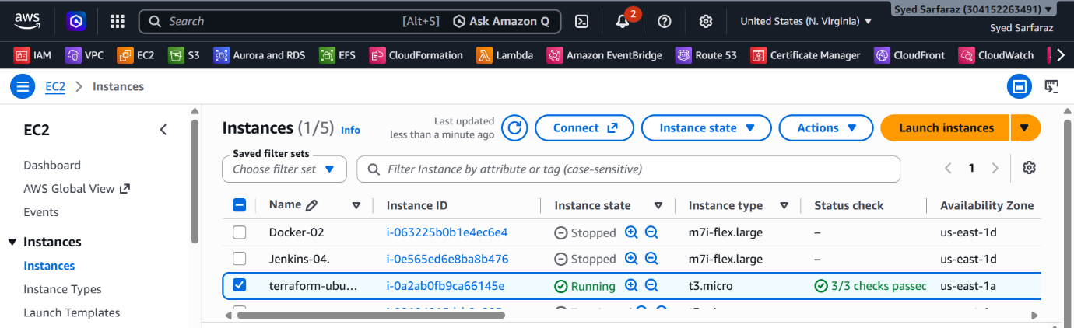
- UBUNTU INSTANCE
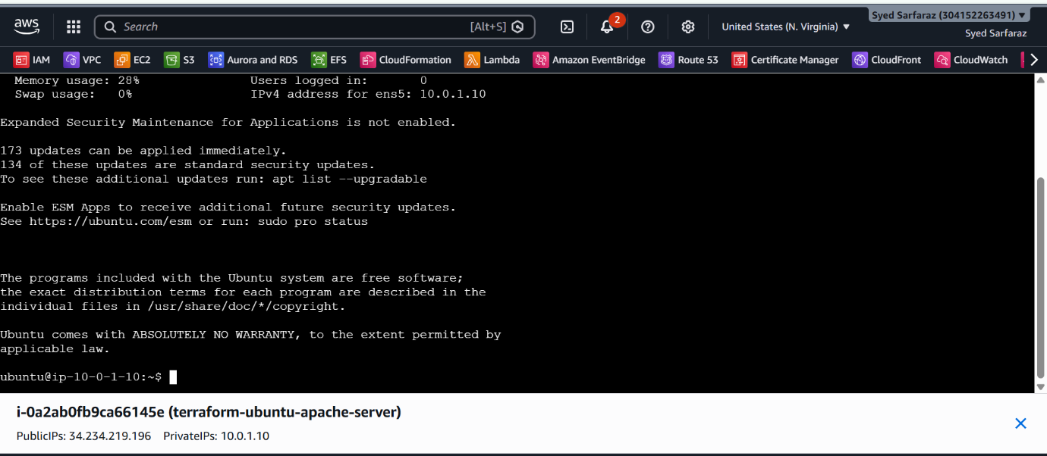

- APACHE2 STATUS
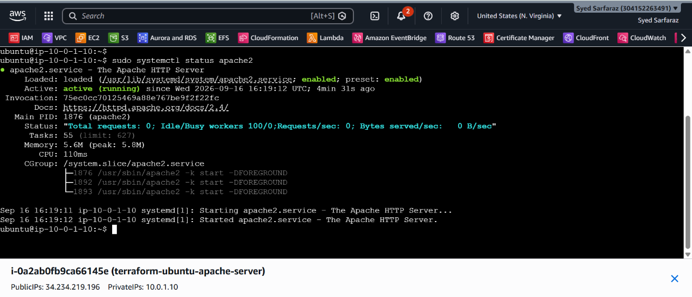

Script:

# ============================================================
# PROVIDER
# ============================================================

terraform {
required_providers {
aws = {
source = "hashicorp/aws"
version = "~> 6.0"
}
}
}

provider "aws" {
region = "us-east-1"
}

# ============================================================
# 1. CREATE VPC
# ============================================================

resource "aws_vpc" "main" {
cidr_block = "10.0.0.0/16"
enable_dns_support = true
enable_dns_hostnames = true

tags = {
Name = "terraform-vpc"
}
}

# ============================================================
# 2. CREATE INTERNET GATEWAY
# ============================================================

resource "aws_internet_gateway" "main" {
vpc_id = aws_vpc.main.id

tags = {
Name = "terraform-internet-gateway"
}
}

# ============================================================
# 3. CREATE CUSTOM ROUTE TABLE
# ============================================================

resource "aws_route_table" "public" {
vpc_id = aws_vpc.main.id

route {
cidr_block = "0.0.0.0/0"
gateway_id = aws_internet_gateway.main.id
}

tags = {
Name = "terraform-public-route-table"
}
}

# ============================================================
# 4. CREATE SUBNET
# ============================================================

resource "aws_subnet" "public" {
vpc_id = aws_vpc.main.id
cidr_block = "10.0.1.0/24"
availability_zone = "us-east-1a"
map_public_ip_on_launch = false

tags = {
Name = "terraform-public-subnet"
}
}

# ============================================================
# 5. ASSOCIATE SUBNET WITH ROUTE TABLE
# ============================================================

resource "aws_route_table_association" "public" {
subnet_id = aws_subnet.public.id
route_table_id = aws_route_table.public.id
}

# ============================================================
# 6. CREATE SECURITY GROUP
# ALLOW PORTS 22, 80, 443
# ============================================================

resource "aws_security_group" "web" {
name = "terraform-web-security-group"
description = "Allow SSH HTTP and HTTPS"
vpc_id = aws_vpc.main.id

# SSH - Port 22
ingress {
description = "SSH"
from_port = 22
to_port = 22
protocol = "tcp"
cidr_blocks = ["0.0.0.0/0"]
}

# HTTP - Port 80
ingress {
description = "HTTP"
from_port = 80
to_port = 80
protocol = "tcp"
cidr_blocks = ["0.0.0.0/0"]
}

# HTTPS - Port 443
ingress {
description = "HTTPS"
from_port = 443
to_port = 443
protocol = "tcp"
cidr_blocks = ["0.0.0.0/0"]
}

# Allow all outbound traffic
egress {
description = "All outbound traffic"
from_port = 0
to_port = 0
protocol = "-1"
cidr_blocks = ["0.0.0.0/0"]
}

tags = {
Name = "terraform-web-security-group"
}
}

# ============================================================
# 7. CREATE NETWORK INTERFACE
# PRIVATE IP = 10.0.1.10
# ============================================================

resource "aws_network_interface" "web" {
subnet_id = aws_subnet.public.id
private_ips = ["10.0.1.10"]
security_groups = [aws_security_group.web.id]

tags = {
Name = "terraform-web-network-interface"
}
}

# ============================================================
# 8. CREATE ELASTIC IP
# ASSIGN IT TO NETWORK INTERFACE
# ============================================================

resource "aws_eip" "web" {
domain = "vpc"
network_interface = aws_network_interface.web.id
associate_with_private_ip = "10.0.1.10"

tags = {
Name = "terraform-web-elastic-ip"
}

depends_on = [
aws_internet_gateway.main
]
}

# ============================================================
# 9. CREATE UBUNTU SERVER
# INSTALL AND ENABLE APACHE2
# ============================================================

resource "aws_instance" "ubuntu" {
ami = "ami-0b6d9d3d33ba97d99"
instance_type = "t3.micro"
key_name = "ubuntu"

network_interface {
network_interface_id = aws_network_interface.web.id
device_index = 0
}

user_data = "#!/bin/bash\napt-get update -y\napt-get install -y apache2\nsystemctl enable apache2\nsystemctl start apache2\necho '<h1>Apache2 Server Created Using Terraform by Sarfaraz</h1>' > /var/www/html/index.html"

tags = {
Name = "terraform-ubuntu-apache-server"
}

depends_on = [
aws_eip.web
]
}

# ============================================================
# OUTPUTS
# ============================================================

output "vpc_id" {
value = aws_vpc.main.id
}

output "internet_gateway_id" {
value = aws_internet_gateway.main.id
}

output "route_table_id" {
value = aws_route_table.public.id
}

output "subnet_id" {
value = aws_subnet.public.id
}

output "security_group_id" {
value = aws_security_group.web.id
}

output "network_interface_id" {
value = aws_network_interface.web.id
}

output "elastic_ip" {
value = aws_eip.web.public_ip
}

output "instance_id" {
value = aws_instance.ubuntu.id
}

output "apache_url" {
value = "http://${aws_eip.web.public_ip}"
}

